H.T No
Regulations:
A14

Sreenidhi Institute of Science and Technology
(An Autonomous Institution)
Code No: 4CC05 Date: 25-Nov-2020 (FN)

B.Tech II-Year II-Semester External Examination, Nov/Dec - 2020 (Supplementary)
Pulse and Digital Circuits (ECM)

Time: 2 Hours Max.Marks:70

Note: a) No additional answer sheets will be provided.
b) All sub-parts of a question must be answered at one place only, otherwise it will not be valued.
c) Missing data can be assumed suitably.

ANSWER ANY 5 OUT OF 8 QUESTIONS. EACH QUESTION CARRIES 14 MARKS.

1. | a) | Draw and explain the output of the low pass RC circuit for different time constants to the step input. | [7M]
 | b) | Design a High pass RC circuit when R=20kΩ and f=50Hzand explain its operation. | [7M]
2. | a) | State and prove clamping circuit theorem. | [7M]
 | b) | For the circuit shown below having an input voltage of 24sin(ωt). Draw the transfer characteristics and output waveform.  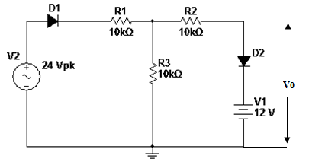 | [7M]
3. | a) | Explain the transistor switching times. | [7M]
 | b) | Sketch the typical transistor common-emitter characteristics. Identify the various regions of the Characteristics and show how V_{CE}(sat) differ with different load resistances. | [7M]
4. | a) | Explain the effect of gain on the hysteresis behavior of Schmitt trigger circuit. How this behavior can be eliminated? | [7M]
 | b) | Show that the monostable multivibrator will act as a pulse width modulator. | [7M]
5. | a) | What are the different methods of generating time base wave forms? Explain about each briefly. | [7M]
 | b) | With neat sketch, Explain about transistor miller time base generator. | [7M]
6. | a) | Compare different types of logic families with respect to the following parameters  i) Propagation delay ii)Noise Margin iii) power dissipation iv) Fan in v)Fan out | [7M]
 | b) | Calculate the expression for gain of bidirectional diode sampling gate. | [7M]
7. | a) | Explain two level clippers with neat diagrams. | [7M]
 | b) | List out the applications of voltage comparator. | [7M]
8. |  | Briefly discuss about working of emitter coupled astable multivibrator. | [14M]

-- 00 -- 00 –

